Hidden Lands,
Forgotten Frontiers

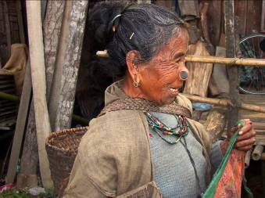

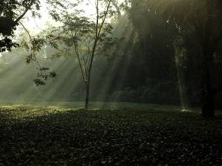

‘A unique journey through India’s incredible north eastern states’
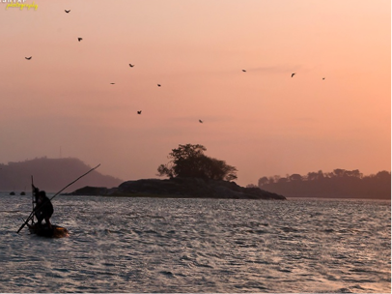

Northeast India
“Its mountains are pregnant with precious stones and silver, its atmosphere is perfumed with tea growing wild and luxuriantly.” The first explorers to penetrate the valleys and mountains of northeast India in the nineteenth century truly believed they had found a lost paradise, a land so fertile that if brought under cultivation it would form “one continual garden”.
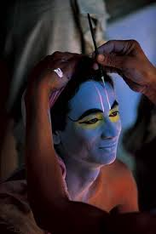
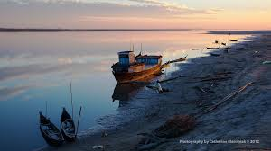
Today northeast India is a paradise found, one of the last remaining frontiers of Asia to be opened up to tourism. Incentive Destinations and Travel on Q are proud to offer discerning travellers a 14-day tour that takes in the best the region has to offer — a rich mixture of wildlife, unique tribal cultures, Hindu festivals, traditional crafts and extraordinary mountain and river scenery.
We begin in Guwahati, spectacularly located on the Brahmaputra River and the site of one of India’s holiest Siva temples. Then we venture deep into the interior of mountainous and remote Arunachal Pradesh state taking in the extraordinarily beautiful Apa Tani plateau with its rice terraces and densely clustered villages of bamboo and timber.
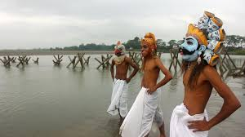
Explore the ruins of the ancient Ahom kingdoms, soak up the Raj-era atmosphere of tea planter’s bungalows and watch silk weavers at work. Wander around the Hindu monasteries of Majuli, the largest riverine island in the world, witness the Raas festival, and visit the graves of servicemen who died defending India from the Japanese advance in World War II. And finally trek through India’s largest and most bio-diverse national park — Namdapha, which is nestled near the borders of Burma and Tibet.

Tour Leader – John Zubrzycki

Your host is writer and journalist John Zubrzycki. John has a degree in South Asian history and Hindi from the Australian National University (Canberra). He has worked in India as a diplomat, consultant and foreign correspondent, spending years searching out its hidden gems. He has written two books on India, both historical biographies, as well as numerous feature articles. He has travelled extensively throughout the northeastern states, and considers them to be the most magical and interesting regions of India.
Itinerary Overview

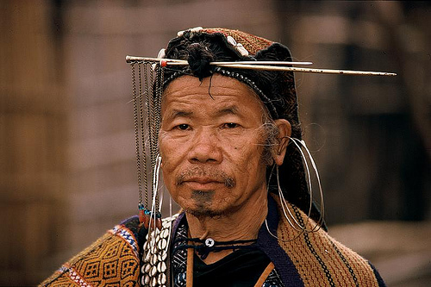
Day 01 Arrive Kolkata
Day 02 Kolkata
Day 03 Fly Kolkata - Guwahati
Day 04 Guwahati – Sualkuchi - Wild Mahseer
Day 05 Wild Mahseer - Ziro
Day 06 Ziro (explore Apa Tani plateau)
Day 07 Ziro - Majuli
Day 08 Majuli
Day 09 Majuli- Jorhat
Day 10 Jorhat- Dibrugarh
Day 11 Dibrugarh - Namphake village - Dibrugarh
Day 12 Dibrugarh - Namdapha
Day 13 Namdapha
Day 14 Namdapha - Dibrugarh
Day 15 Fly Dibrugarh – Kolkata

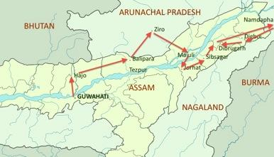
Making a difference: Boat clinics on the Brahmaputra
Most of the villages along the Brahmaputra River have no electricity, roads, secondary schools, clinics or proper toilets. Ten years ago, the Centre for North East Studies and Policy Research (C-NES) — realising the government was not in the position to build clinics on these islands and that the people could not access services on the mainland — decided to take healthcare to the islands by providing boat clinics. C-NES started with one boat and a full-time team of five. Today, it has more than 150 workers spread across 13 districts in Assam with 15 boat clinics, reaching nearly 800,000 people in partnership with the National Rural Health Mission. Your $200 donation, included in the cost of the tour, will go towards providing services to those most in need. As part of the tour we will visit one of the clinics to see how your donation will be spent.
Day to Day Itinerary
DAY 01, Nov 19 (Thu) ARRIVE KOLKATA
After clearing Customs and Immigration formalities, proceed towards the arrival lounge of the airport where you will be met by our representatives, welcomed with garlands and transferred to by private transport to the hotel. Check-in is available from 2pm.
The capital of the British Raj until 1911, Kolkata retains its imperial splendour with its grand buildings and rich colonial heritage. Kolkata is frequently referred to as India’s intellectual capital, the birthplace of some of its best-known writers, artists and filmmakers. Its teeming bazaars and stately mansions are testimony to its prominence as the commercial hub of eastern India. Kolkata is a vibrant, many-layered city with a rich cultural life and many fascinating areas to explore.
Overnight: The Taj Bengal Kolkata (Deluxe Room)
www.tajhotels.com/Taj-Bengal
Meals: None
DAY 02, Nov 20 (Fri) KOLKATA
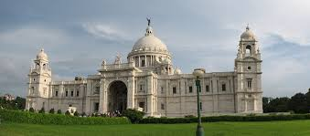
This morning we take an orientation tour of the city, including the Victoria Memorial. Funded by Indian princes, the British government and the former Viceroy of India Lord Curzon, it was inaugurated by the Prince of Wales in 1921. Constructed from the same marble use by the Mughal emperor Shah Jahan to build the Taj Mahal, the Memorial exudes majesty and elegance. It houses a number of galleries displaying a rich collection of sculpture, painting, armaments and other historical treasures. Later we visit the Marble Palace. The sprawling 19th century mansion of the Mullick family houses an eclectic collection of art and antiques ranging from Old Masters to statues of Hindu gods. The palace earned its name from the 90 varieties of patterned marble on its floors. There are paintings by Reubens and Joshua Reynolds, Dresden figurines and Bohemian goblets. The author Geoffrey Moorhouse described it as ‘the richest, the quaintest, the eeriest, the most haphazard and the most ridiculous, the most astounding and the most loveable’ place in Kolkata. We also visit the 18th century ancestral home of India’s greatest writer Rabindranath Tagore. The house has been restored to reflect the way the household looked when the Tagore family lived there and currently serves as the Tagore museum. Time permitting, we visit Kumhar Tulli, a traditional potter’s quarters and see the local sculptors at work.
Overnight: The Taj Bengal Kolkata (Deluxe Room)
www.tajhotels.com/Taj-Bengal
Meals: Breakfast, lunch, dinner
DAY 03, Nov 21 (Sat) FLY KOLKATA -- GUWAHATI

We are transferred to the airport to board our flight to Guwahati,

Jet Airways 9W 2479 12.10-13.50 or we may take an earlier option on Air India

Air India AI 729 09.50-10.55

Once known as Pragjyotishpur, (the city of astrology) Guwahati on the south bank of the Brahmaputra is the gateway to Northeast India. The commercial hub of the city is Fancy Bazaar, a typically chaotic Indian market selling all kinds of goods. The Guwahati Tea Auction centre is the largest in the world.
A feature of this journey is the Brahmaputra, one of the great rivers of the world. The Brahmaputra ‘the son of Brahma’, rises in a mythical spring near the sacred Kailas peak in Tibet, then flows for nearly 3000 kilometres through Tibet, India and Bangladesh before emptying its waters into the Bay of Bengal.
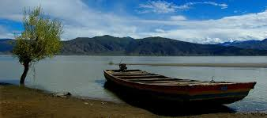
It starts its journey by gathering snow melt from the northern slopes of the Himalayan Ranges before flowing east across some of the most inhospitable terrain in the world. It then turns abruptly southwards, cutting through the Himalayan peaks and creating one of the deepest gorges in the world, before reaching the wide, fertile plains of Assam.
In the afternoon, we visit the Kamakhya temple on top of Neelachal Hill. Built in classical Assamese style, the temple is one of the great pilgrimage destinations of India. Kamakhya means ‘eye of desire’ and the temple known as a centre for Tantric Hinduism and the worship of Shakti (female spiritual power). Goats, pigeons and the occasional buffalo are ritually beheaded is its small womb-like sanctum. The road leading up to the temple is lined by shops and stalls catering to the needs pilgrims and selling ornaments, statues, beads, pictures and other items used for puja or worship.
Overnight: Hotel Radisson Blu (Standard Room)
http://www.radissonblu.com/hotel-guwahati
Meals: Breakfast, Lunch & Dinner
DAY 04, Nov 22 (Sun): GUWAHATI–UALKUCHI – HAJO – WILD MAHSEER (220kms/5 hr drive)

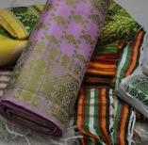
After breakfast, we drive to the town of Sualkuchi with packed lunch. Sualkuchi is famous for producing the best silk fabric in Assam. Bengal and Assam were the earliest centres of silk weaving in India and the 17,000 looms of Sualkuchi continue this tradition. We visit its silk weaving workshops, witnessing the process of silk manufacture from cocoon to spinning to dyeing and finally to hand weaving exquisite saris, shawls and dress lengths.
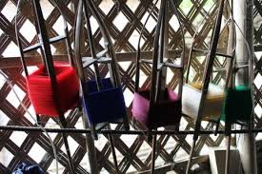
We continue our journey to Hajo, a place sacred to Hindus, Muslims and Buddhists. The oldest temple here is the 6th century Hayagriva Madhab. The Buddhist origins of the temple are attributed to a row of caparisoned elephants carved into the plinth. Some Buddhists believe Hajo is the place where Buddha died. Muslims attribute the name Hajo to the Haj, the pilgrimage to Mecca. We also visit families engaged in traditional brass metal work.
Tea was first discovered growing wild in the jungles of Assam in 1823 by Robert Bruce. With its rich, loamy soil, cool and arid winters and hot humid rainy seasons the Brahmaputra valley is considered idea for growing tea. The first cargo of tea was transported by steamer to Calcutta in 1838 with a cargo bound for London. India is the world’s largest producer and consumer of tea and the 2000 tea plantations dotted around foothills of the Brahmaputra valley in Assam accounts for around half of this production. Tea is mostly harvested by women, before being dried and sent to centres such as Guwahati and Kolkata.
Overnight: Wild Mahseer (heritage property)
www.wildmahseer.com
Meals: Breakfast, Lunch & Dinner
DAY 05, Nov 23 (Mon): WILD MAHSEER – ZIRO (300 kms/approx 7 hr drive)


We drive to Ziro in the central Part of Arunachal Pradesh. Stretching from Bhutan in the east to Burma in the west and covering 84,000 sq km of mountainous jungle-clad terrain, Arunachal Pradesh is India’s most unexplored and least populated state. The snow-capped Himalayan range forms a backdrop to its steep valleys and plateaus. Arunachal Pradesh is also the most ethnically diverse state in India with dozens of distinct tribal groups.
Ziro on the Apatani plateau has been described as one of the most beautiful landscapes in all of India. The wood and bamboo villages of the Apatani people are spread out across a large plateau Terraced rice fields, set against the backdrop of jungle-covered mountains and the perpetual snow of the Himalayan range in the distance. The Apatani tribes who live in tightly packed villages are Ziro's greatest attraction. The older men tie the hair in top-knots and tattoo their faces. Apatani women wear wooden nose plugs and also tattoo their faces, a practice that is no longer followed by the younger generation. The Apatani have evolved a sophisticated system of paddy cultivation.
Overnight: Abasa Homestay (07 rooms)
*beyond 7 rooms – we will be using Ziro Valley Resort (Non A/C Rooms)
Meals: Breakfast, Lunch & Dinner
DAY 06, Nov 24 (Tue): ZIRO
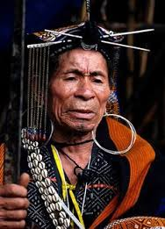
The highlight of the day will be visiting several traditional Apatani villages close to Ziro. Each village has a totem and animist ritual sacrificial altar. Local crafts include cane baskets and head wear as well as textile weaving. We will also visit the museum and emporium.
Overnight: Abasa Homestay (07 rooms)
*beyond 7 rooms – we will be using Ziro Valley Resort (Non A/C Rooms)
Meals: Breakfast, Lunch & Dinner
DAY 07, Nov 25 (Wed): ZIRO–MAJULI (5hr drive/30min ferry)

From Ziro we drive to North Lakhimpur to take a ferry to Majuli Island. The main tribal groups living on Majuli are the Mishing, the Deoris and the Sonowal Kacharis. To protect against flooding, houses are built on stilts two metres above the ground. Erosion by floods has halved the island’s size in the last century.

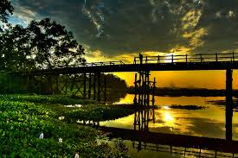
Situated in the middle of the wide and peaceful Brahmaputra, Majuli is the largest inhabited river island in the world, and is awaiting World Heritage status by UNESCO. It is the seat of Vaishnava culture in Assam and the nucleus of Assam’s cultural heritage. According to Assamese folklore, Majuli was born from the left breast of Kali that had fallen from the hands of the Hindu god Shiva. The great 15th century Assamese reformer and saint, Shankardeva set up ‘satras’ or Vaishnavite monasteries. The Vaishnavite’s eschew caste and idol worship, focusing instead on dance and melodramatic playacting from the Bhagavad Gita. Some 20 of these satras still remain, training young disciples. It’s a place of great natural beauty.

Overnight: Mepo Okum (8 cottages+02 tents) Non A/C Rooms
Traditional Mishing cottages with attached bath, hot water in bucket. Tents have attached bath.
Meals: Breakfast, Lunch & Dinner
DAY 08, Nov 26 (Thu): MAJULI

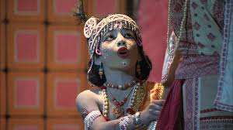
We spend the day visiting satras. As centres of learning, these institutions also act as repositories of Assam’s history with collections of antiques, utensils, weapons, jewellery and royal and sacred relics. In the evening we witness one of the highlights of the tour - the festival of Raas in the honour of Lord Krishna and his eternal love for Radha. In this two day dusk to dawn festival, satras vie to outdo each other in a showcase of music, dance and theatre rarely seen by foreigners.
Overnight: Mepo Okum
Traditional Mishing cottages with attached bath, hot water in bucket. Tents have attached bath.
Meals: Breakfast, Lunch & Dinner
DAY 09, Nov 27 (Fri): MAJULI – JORHAT (25 kms/approx 30 min drive + 45 Min ferry ride)

In the morning we visit Uttar Kamalabari Satra. This large and very peaceful satra, or monastery, is a centre of art, culture, literature & classical studies. The Kamalabari Satra has been producing great Assamese cultural figures and is the home to legendary musicians and performing artists. Along the way we look out for some of the 100 bird species that inhabit the island. From there is it a ferry ride and a short drive to Jorhat.

Overnight: Banyan Groove (07 Rooms only) (Standard A/C Rooms)
http://www.heritagehotelsofindia.com/assam/banyan-grove.html
OR
Overnight: Kaziranga Golf Resort (16 rooms) (Standard A/C Rooms)
www.kazirangagolfresort.com
Meals: Breakfast, Lunch & Dinner
DAY 10, Nov 28 (Sat): JORHAT – DIBRUGARH (150 kms/approx 3hr drive)

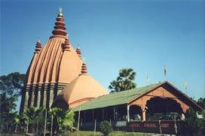
Enroute to Dibrugarh, also known as “Tea City”, we visit Sibsagar, the one-time capital of the Ahom kings of Assam. Shan by origin (Assam and Siam share the same derivation), the Ahom kings converted to Hinduism and ruled Assam for some 700 years until the 1820s. Their culture and the architecture of the temples and palaces is a strange and delightful amalgam of Indian and South East Asian styles. Next to the temple in Sibsagar is believed to be the world’s largest hand-excavated reservoir. Three typical Ahom temple towers rise about the tank’s southern end. Dibrugarh is surrounded by tea estates and our accommodation is in the heritage-listed Mancotta Tea Bungalow.

Overnight: Mancotta Tea Estate Bungalow (heritage property)
http://www.nivalink.com/hotel/changbungalow
OR
Overnight: Natraj hotel (3 star)
http://hotelnatraj.net
Meals: Breakfast, Lunch & Dinner

DAY 11, Nov 29 (Sun): DIBRUGARH–NAMPHAKE—DIBRUGARH (90km / approx 3hr drive)

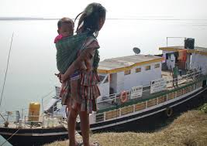
From Dibrugarh we proceed to Namphake village. Spread three kilometers along the banks of the Dihing, a tributary of the Brahmaputra, this picturesque village has an enticing old-world charm. It is the largest of the Tai-Phake villages in Assam, with around 70 families who trace their ancestry to the great Tai race. The people speak a dialect similar to the Thai language and still follow traditional Tai customs and dress code. The village is also home to the Namphake Buddhist Monastery, one of the oldest and most respected Buddhist monasteries in Assam.

We then visit one of the Boat Clinics run by the Centre for North East Studies in association with the National Rural Health Mission. The NGO runs a network of teams, doctors, nurses, lab technicians and pharmacists as well as district organisers and community workers. Your $200 donation, included in the cost of the tour, will help provide basic health care to many of the 3 million people who live on the banks of the Brahmaputra and its islands.

Overnight: Mancotta Tea Estate Bungalows (heritage property)
OR
Overnight: Natraj hotel (3 star)
Meals: Breakfast, Lunch & Dinner

DAY 12, Nov 30 (Mon): DIBRUGARH – DEBAN (NAMDAPHA) (180km/approx 6hr drive)

After breakfast we drive to Deban in Namdapha National Park. A local guide will take us on treks through the dense forests, visiting local tribal groups.
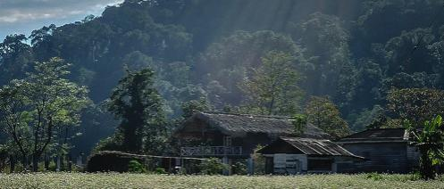
Wild and remote and covering an area of 1985 sq km, Namdapha National Park in eastern Arunachal Pradesh is the largest, the most remote and some say the best wildlife reserve in India. Home for a formidable diversity of plants and animals, it ranges in height from near sea level to 4500 meters, its extremities still unexplored and spilling over the border into Burma. Namdapha is situated in the beautiful Noa-Dihing valley. It boasts more than a 1000 plant species, over 500 bird species and a diversity of animal species that includes tigers, leopards, deer, flying squirrels, red pandas, bears. It is the only park in India where the four big cats – tigers, leopard, clouded leopard and the snow leopard can be found.

Overnight: Deban Guest House (09 rooms - Standard Non A/C Rooms)
Simple and basic with attached bath, 04 rooms have Indian style toilets.

Meals: Breakfast, Lunch & Dinner

DAY 13, Dec 1 (Tue): DAY TRIP AT NAMDAPHA NATIONAL PARK

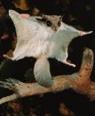
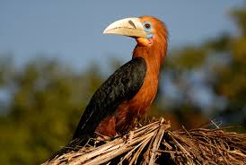
Today we will explore the park on elephant back (subject to weather conditions). Alternatively we can offer soft treks to explore the park. The park is a biodiversity hotspot and the 3rd largest National park in India. You are most likely to see flying squirrels, the slow loris and other smaller mammals such as deer and red panda.

Overnight: Deban Guest House
Simple and basic all with attached bath, 04 rooms have Indian style toilets.
Meals: Breakfast, Lunch & Dinner
DAY 14, Dec 2 (Wed): NAMDAPHA NATIONAL PARK–DIGBOI–DIBRUGARH (180km/6hr drive)

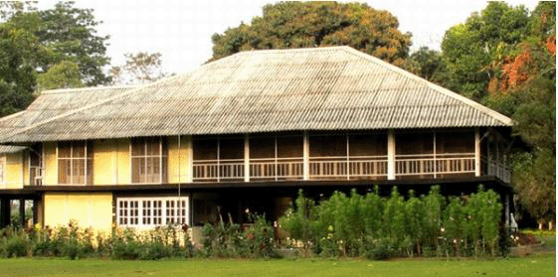
After breakfast we drive to Dibrugarh, stopping enroute at Digboi.

Surrounded by numerous tea gardens and mystic blue hills, Digboi is home to the oldest continuing oil field and refinery in the world. Quaint teak bungalows built by Burmah Oil are dotted around the landscape. We visit the oil museum and war cemetery. Thousands of allied troops were stationed here during World War II.

Overnight: Mancotta Tea Estate Bungalows (heritage property)
http://www.nivalink.com/hotel/changbungalow
OR
Overnight: Natraj hotel (3 star), 6 rooms
Meals: Breakfast, Lunch & Dinner
DAY 15, Dec 3 (Thu): DIBRUGARH – KOLKATA – DEPART

Late in the morning we are transferred to Dibrugarh airport for our flight to Kolkata (via Guwahati)

Dibrugarh-Guwahati Jet Airways 9W 7080 13.55-14.55
Guwahati-Kolkata Jet Airways 9W 2364 15.25-16.40
As most flights to Australia depart very late in the evening, you could either stay at the airport and choose to have a light dinner at one of the food outlets there, or we can arrange to take you to an airport hotel where you can have dinner and relax (at extra cost).
END OF ARRANGEMENTS

PRICES

Prices are based on a minimum of 6 participants. If the final number is below 6, then a surcharge will apply.

Price EXCLUSIVE of international airfares and visa:

Twin Share: $7835 per person
Single Supplement: $1300
Domestic Airfares: $290 per person

Approximate airfare on Singapore airlines to Kolkata return from Sydney is $1453 inclusive of tax in economy class

PRICE INCLUSIONS:
- Accommodation for 14 nights on double occupancy basis in the mentioned hotels or similar.
- All meals starting with breakfast on Day 02 and ending with breakfast on day of departure.
- Welcome and Farewell dinners with Indian house wines.
- Transportation by Scorpios or Xylo’s or similar 4 wheel drives (03 guests per vehicle) throughout except at Kolkata where Mini Coaches will be provided.
- Mineral water during transfers and sightseeing.
- Entry fees, monuments fees, parking fees, road taxes, village visits and local sightseeing as per programme.
- Cultural Programme at Majuli.
- Permit charges for visiting Arunachal Pradesh.
- Public ferry charges.
- Services of accompanying English speaking guide from arrival in Guwahati until departure and a local guide in Kolkata.
- AU$ 200 per person as donation to the Boat Clinics.
- All tipping throughout the tour.
- All currently applicable taxes.

PRICE EXCLUSIONS:
- International, visa fees, airport tax or any kind of insurance cover
- Drinks of any nature, any other meals than those mentioned in the itinerary
- Still and video camera fee at monuments and game parks
- Items of personal nature like drinks, laundry, telephone calls, tips, camera fees etc
- Liability for change in itinerary due to reasons beyond our control like change in flight and train schedule; cancellation of flights, political disturbances, natural phenomenon,
- Any other item not specifically mentioned above as 'INCLUDED'

GENERAL CONDITIONS:
- Check-in time is 2.00pm and Check-Out time is 11.00 am
- All prices are subject to any revision of tax and tariff structure
- All prices are subject to change due to the fluctuation of exchange in the local currency
- Travel insurance is compulsory
- A visa for India is required and is not included in the above cost

